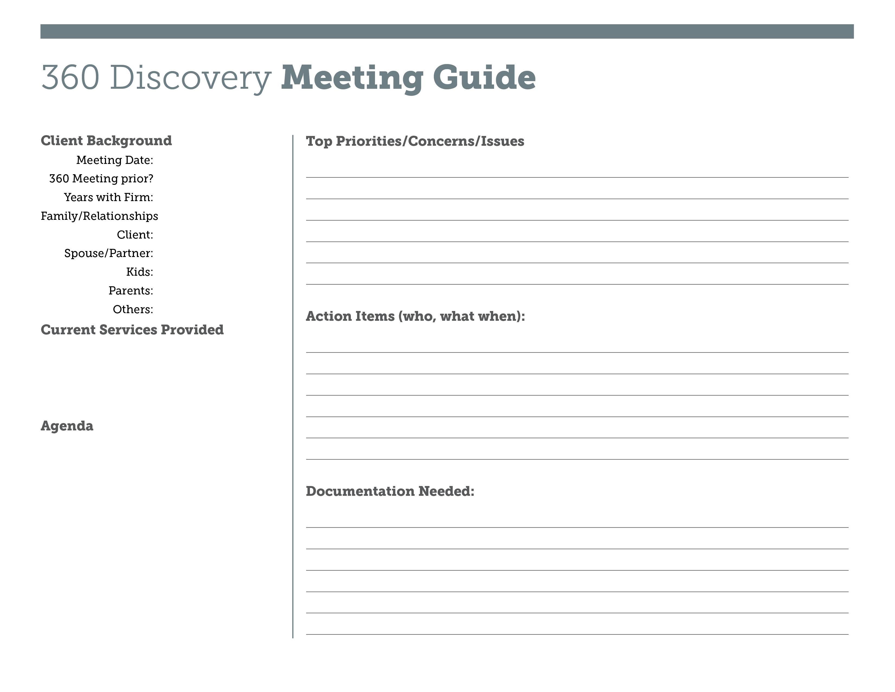

Note: These are customizable templates that you may want to use with your clients. You should consult with your legal counsel and compliance advisors prior to use.

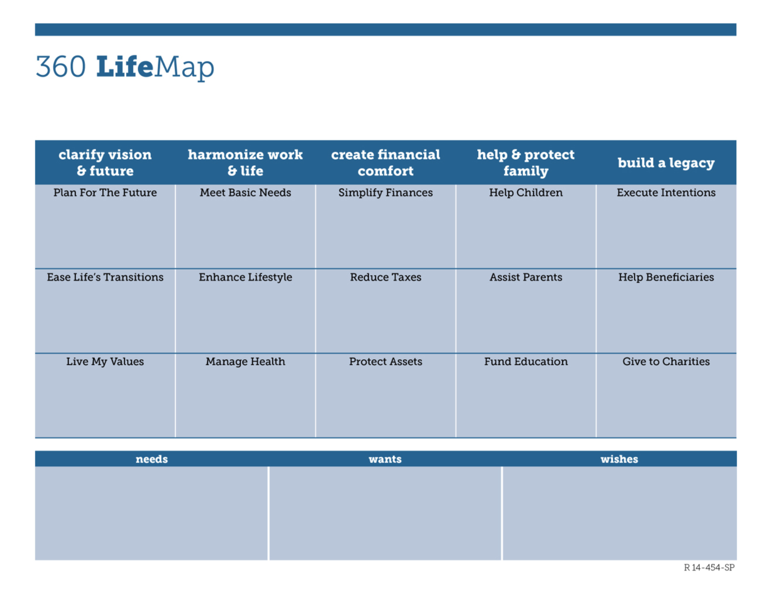

Note: These are customizable templates that you may want to use with your clients. You should consult with your legal counsel and compliance advisors prior to use.

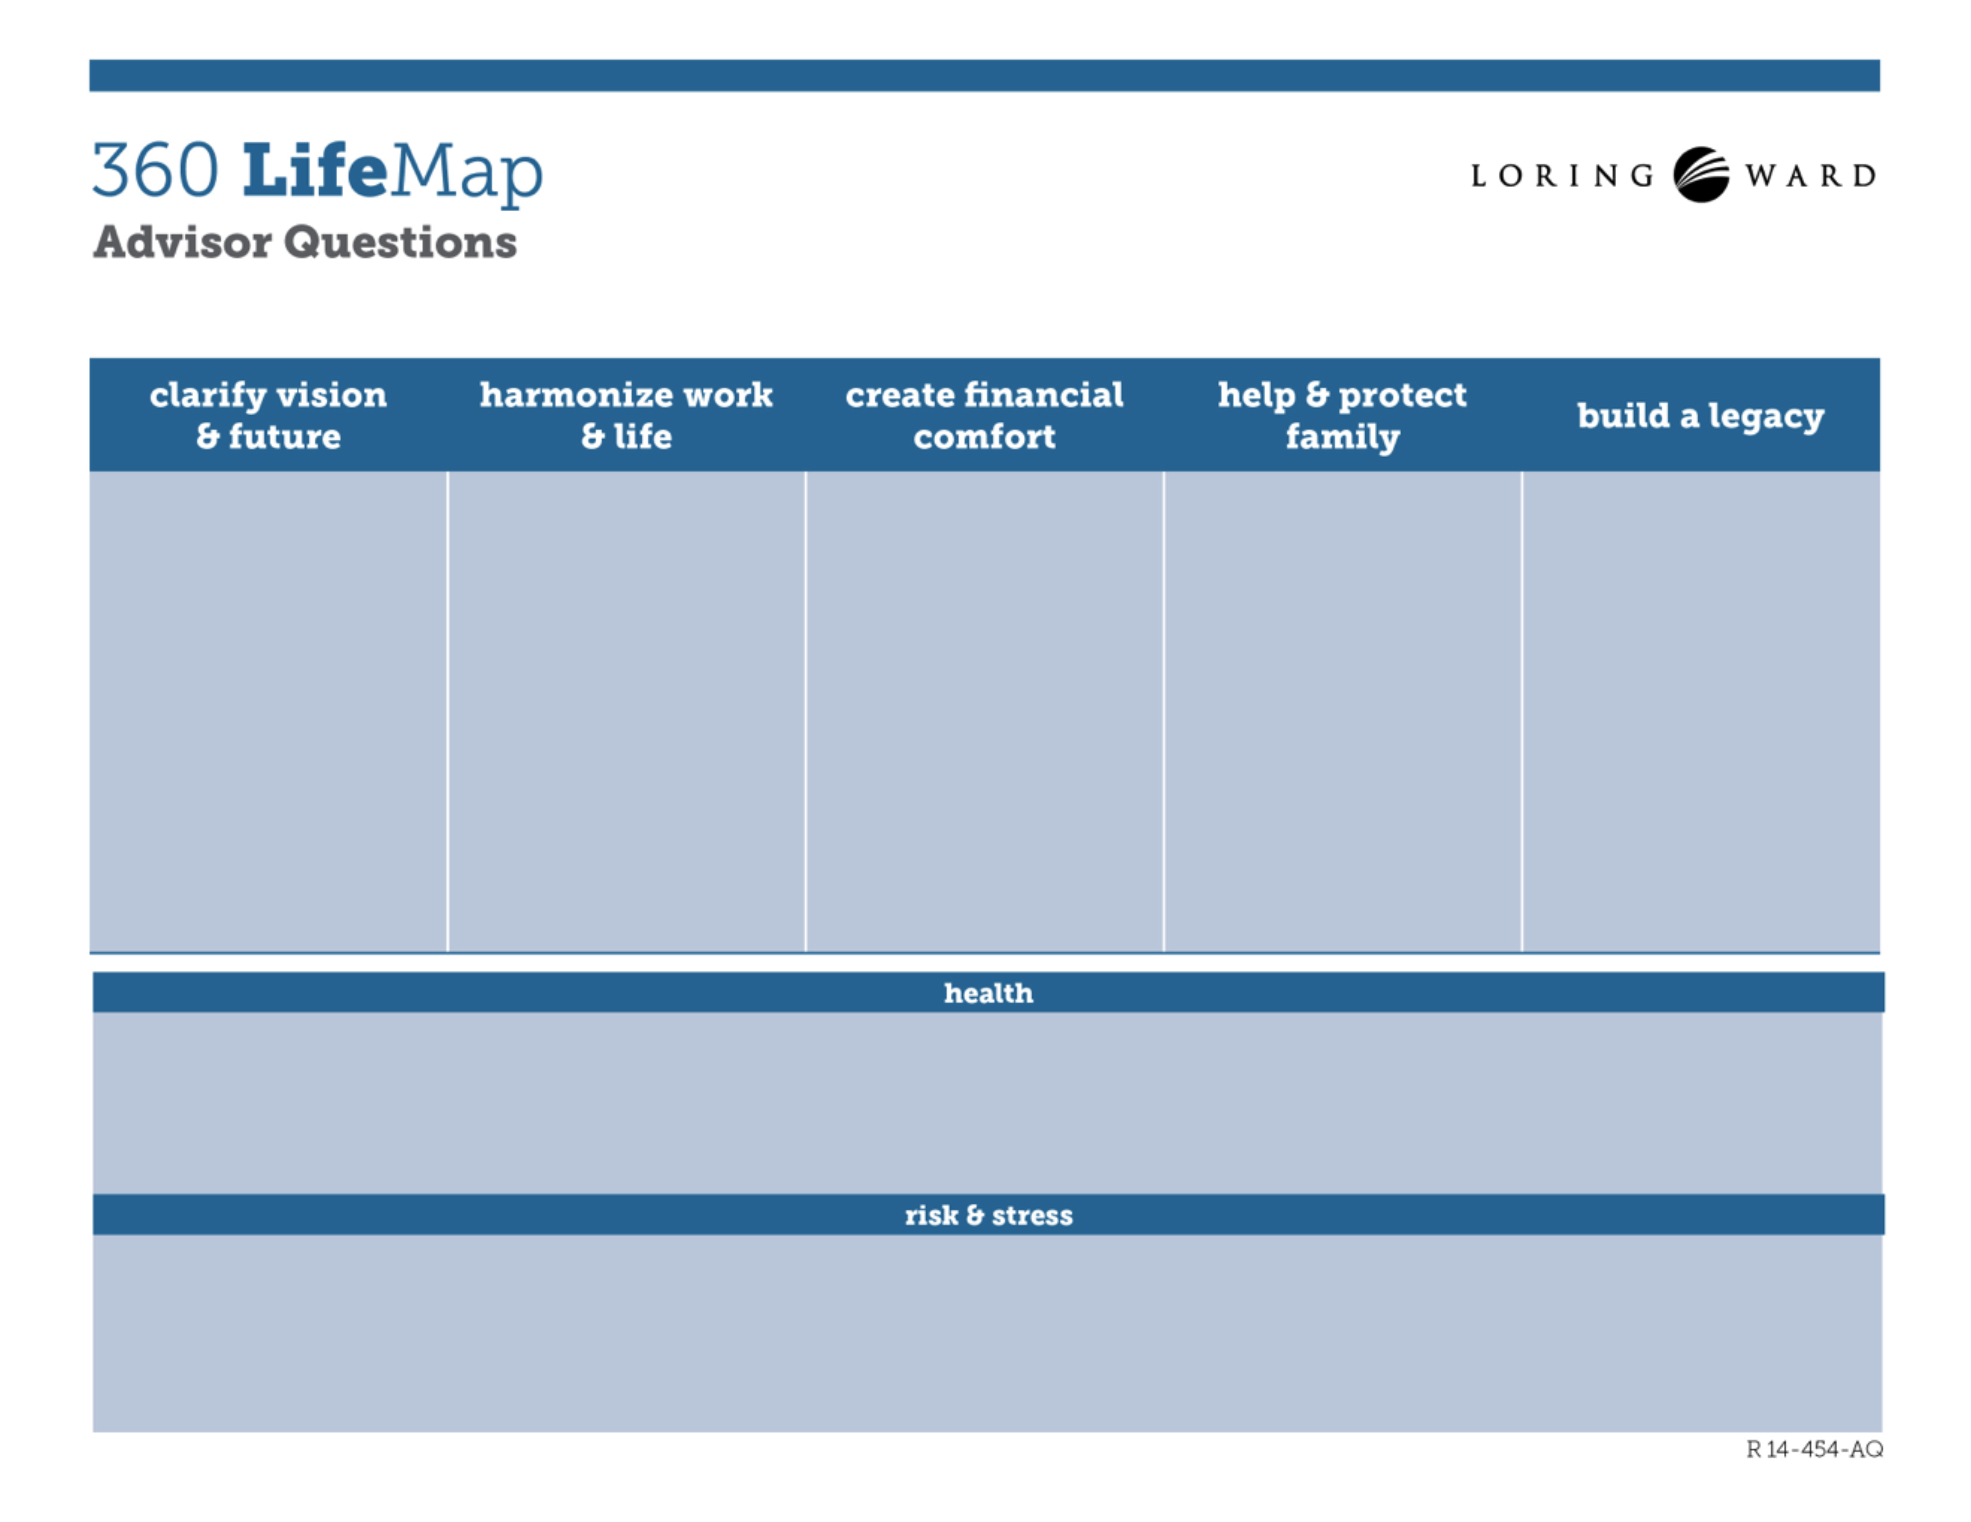

* What concerns you about either your health or the health of your spouse or family?
* What changes do you see occurring in your family health situation that I should understand?
* What plans have you put in place to protect your lifestyle or your family in the event of a health challenge?
* How did you feel about the markets during the financial crisis of 2008?
* How would you react if we experienced another market drop like 2008?
* What haven’t I asked you that I should have?
* What plans have you made for the future?
* What values impact your views about the future?
* As you move through life’s stages, what  
  vision comes to mind?
* How do you like to spend your time when you’re not working?   
  How might that evolve?
* What do you enjoy most about your work? Might that change in retirement?
* What kinds of financial issues keep you up at night?
* What are the biggest financial mistakes you’ve made or   
  avoided?
* What aspects of your finances do you feel are uncomfortable? What could be improved?
* Who else in your   
  family will be   
  impacted by the plans we put in place?
* What family issues should we consider?
* What ways would you like to financially help your family?
* How would you like others to remember you?
* How are you making sure that your intentions will be carried out?
* Are there important charities that you’d like to benefit?

Note: These are customizable templates that you may want to use with your clients. You should consult with your legal counsel and compliance advisors prior to use.